Step-ends for pools still to be constructed „N+S“
The models COMFORT 150, COMFORT 220 and OCTA ECK 140 all have PVC strips which are suitable for 1,5 mm thick liners to be welded on. The steps are placed in corners and fixed with bolts. All transition joints filled with silicone. Please see the left picture below. It is also possible to install the step-end in an existing pool. A 20 cm wide strip of liner is welded on the PVC strip as well as on the existing liner.

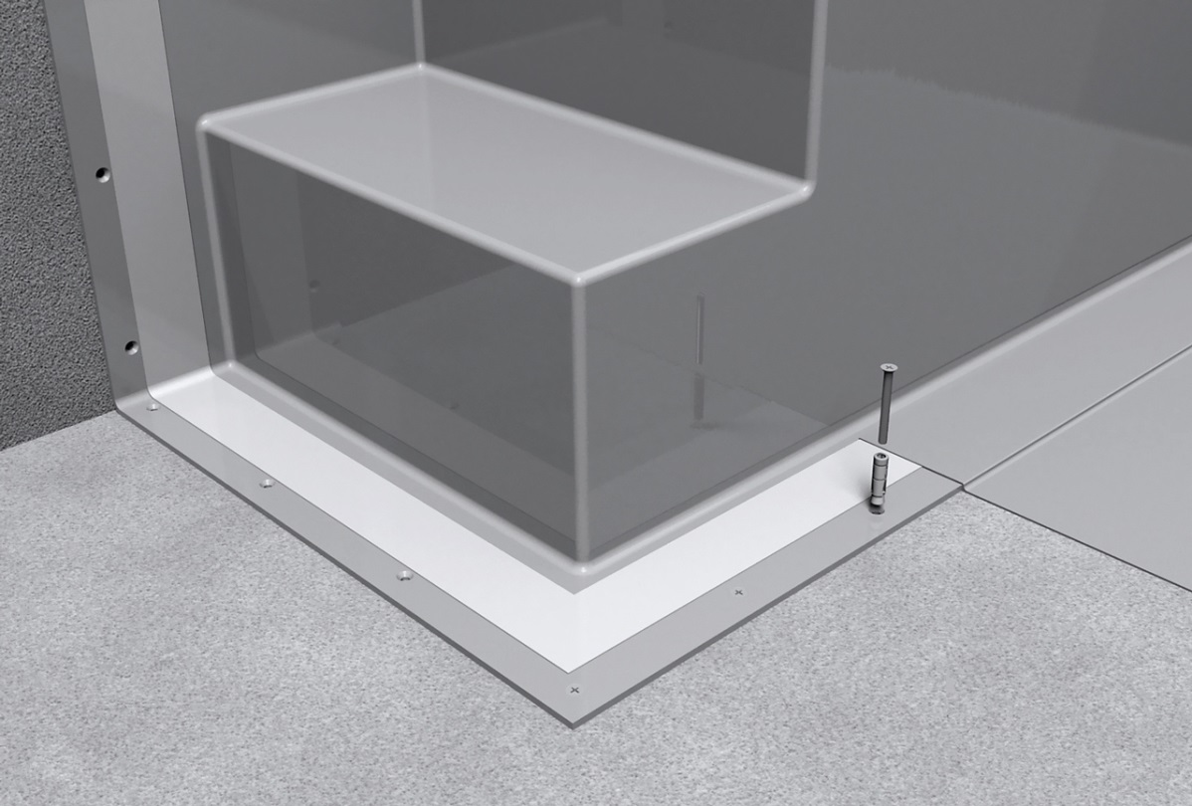

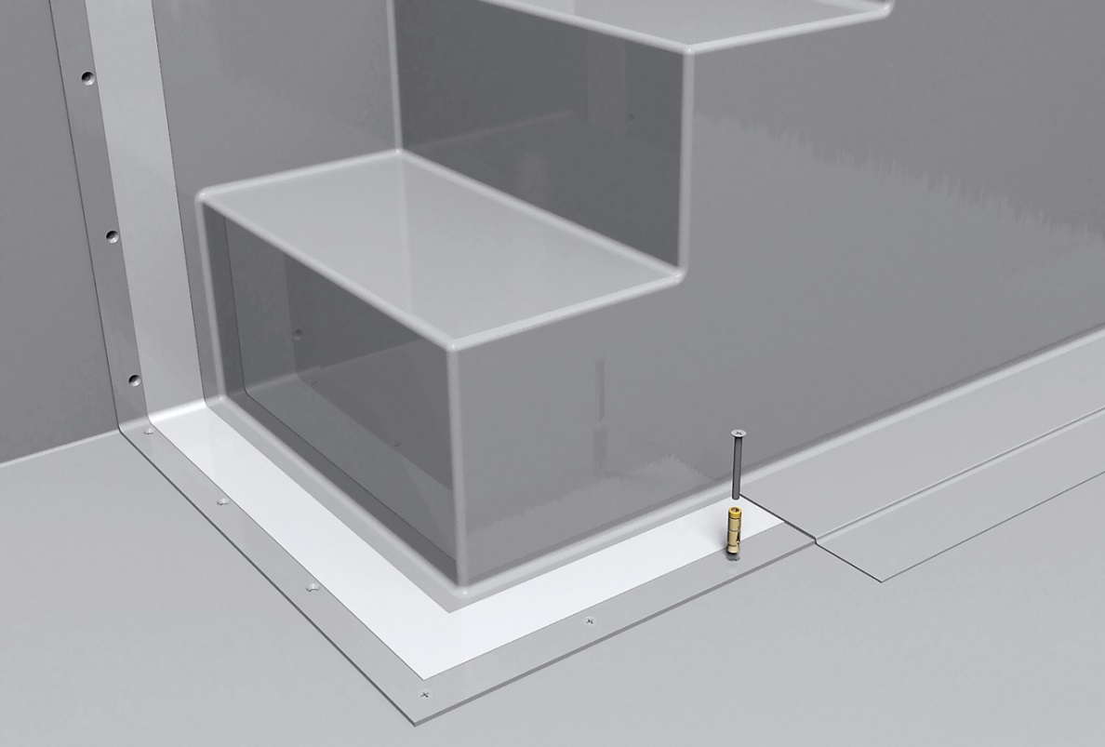

Octa Eck 140 “N+S”

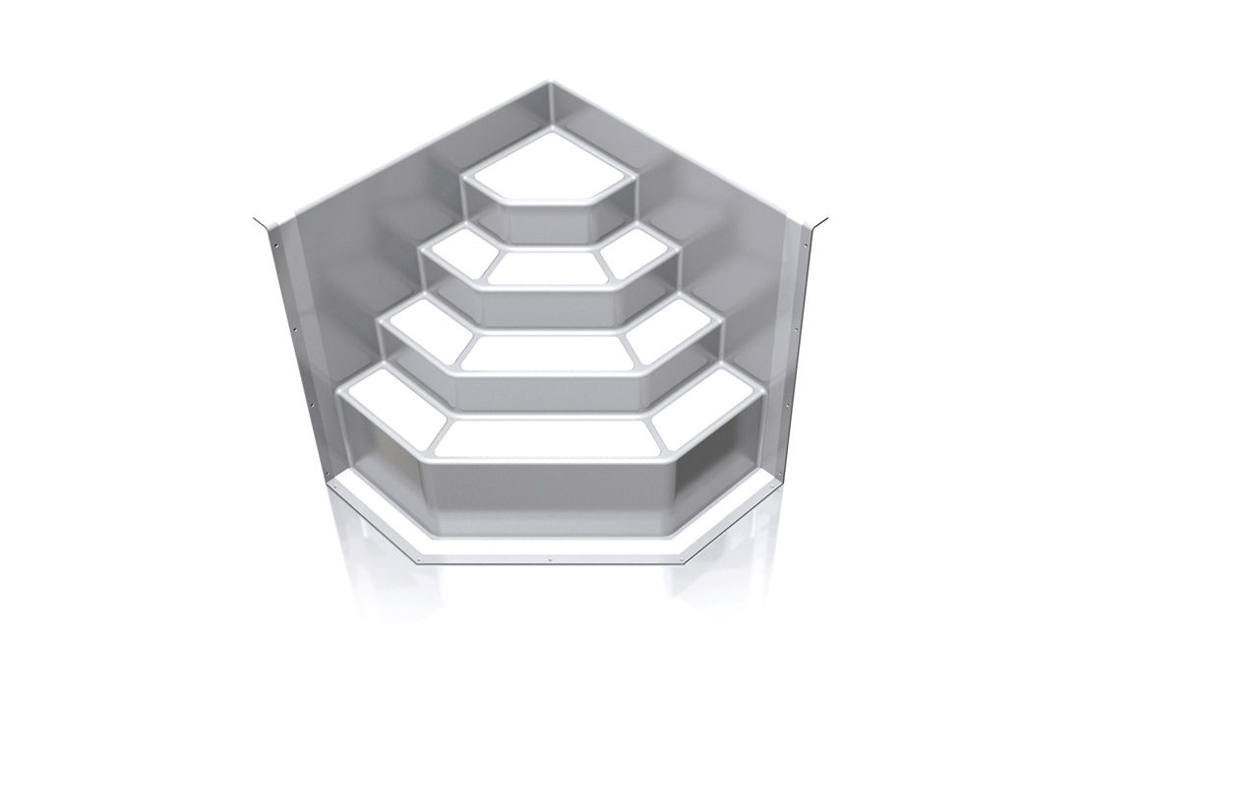

Dimensions: 1400 mm x 1400 mm x 1510 mm

