Malaga 325

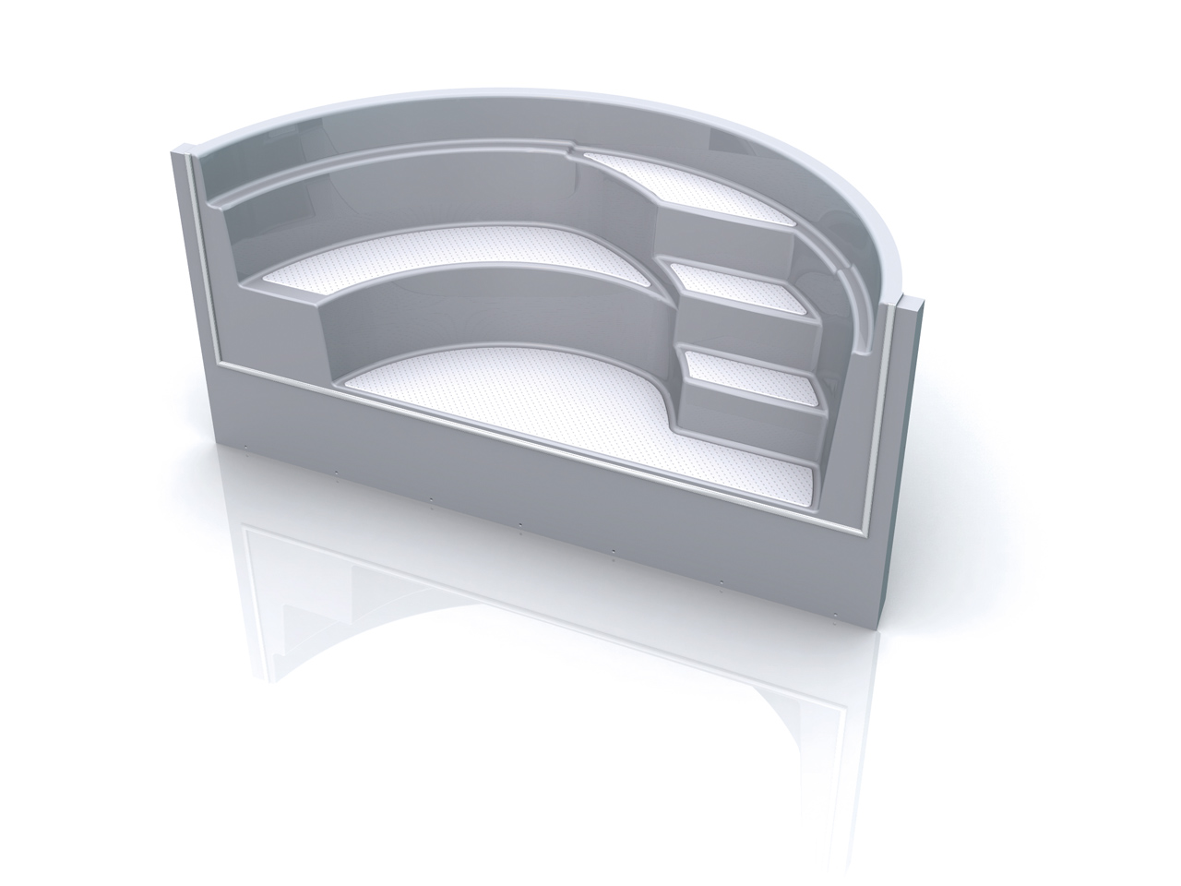

Dimensions: 1333 mm x 3250 mm x 1500 mm

Radius: 1500 mm

