Malaga 225

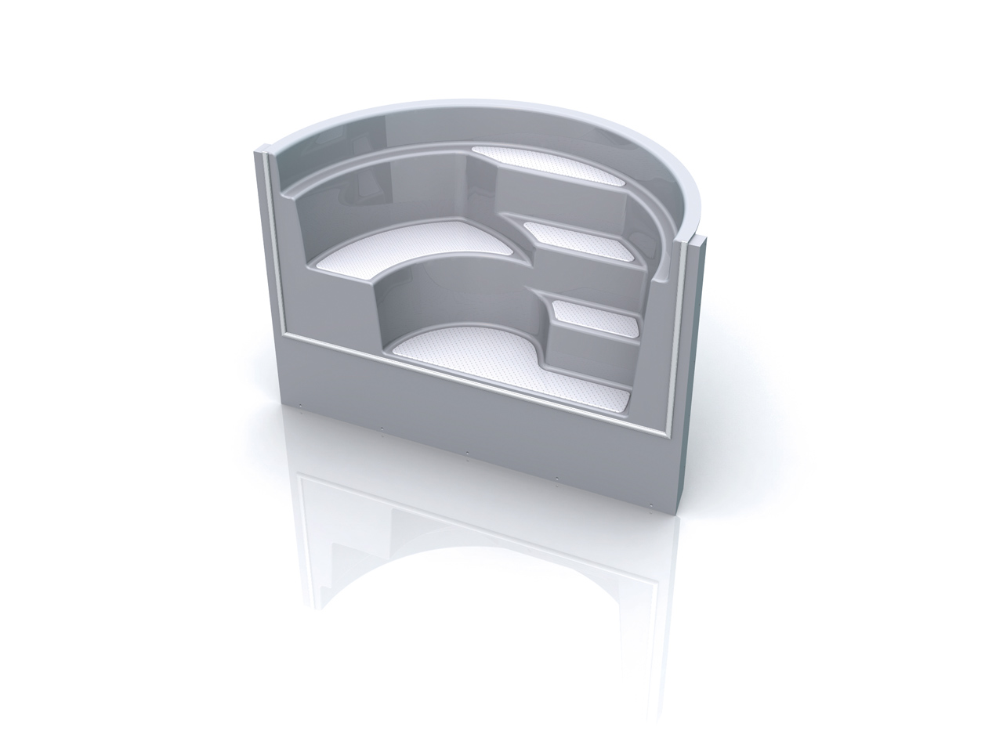

Dimensions: 1075 mm x 2250 mm x 1500 mm

Radius: 1000 mm

