Kanto 300
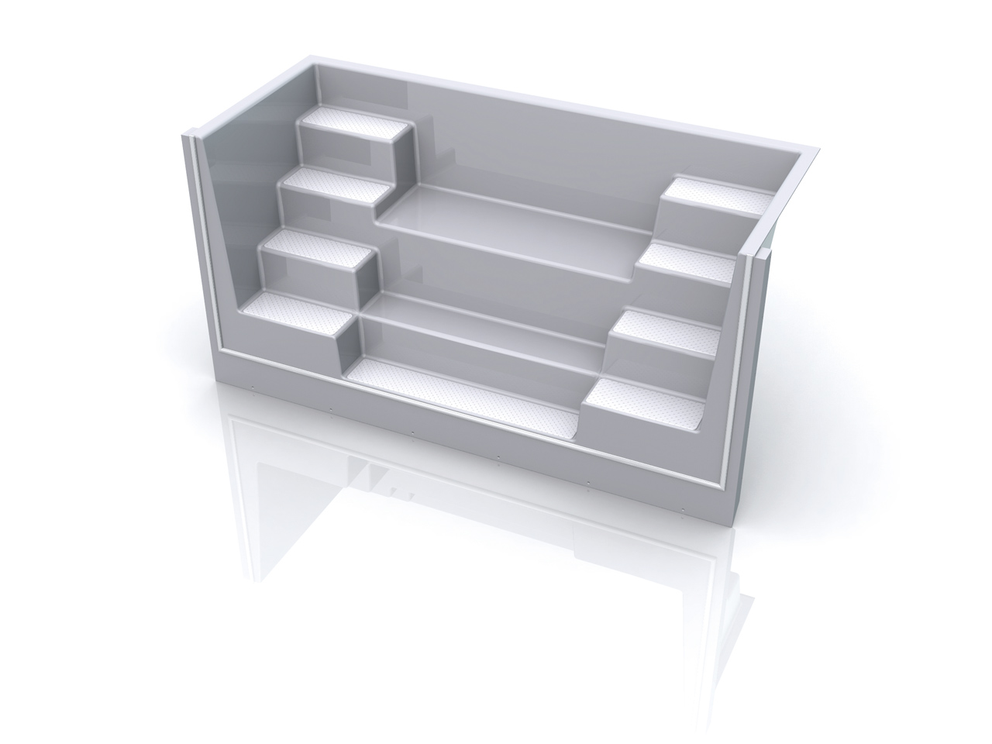

The Kanto step is available in 250 cm or 300 cm wide. Two new designs of entry steps with anti-slip treads leading you into your pool with ease. A central seating bench can be equipped with flow and massage equipment as required, allowing you to enjoy some relaxation after your workout.

Dimensions: 1165 mm x 3000 mm x 1500 mm

