Kanto 250
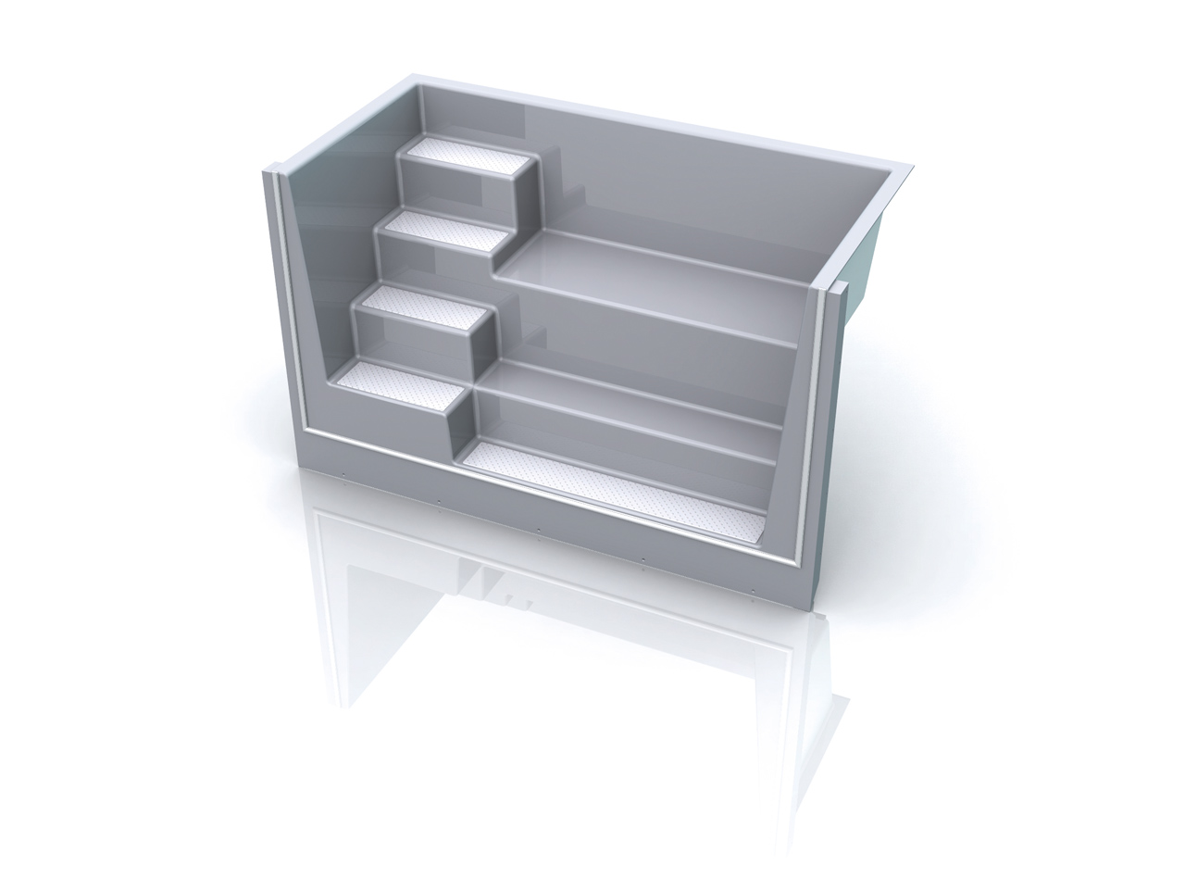

Dimensions: 1165 mm x 2500 mm x 1500 mm

5 steps plus sitting lounge. Suitable for counter current installation. Suitable for air channel system.

