Step-ends „U“

The following models ELEGANZ U 60 and OCTA 140 U are designed for all pools. They are placed in the water and can be used in existing pools.
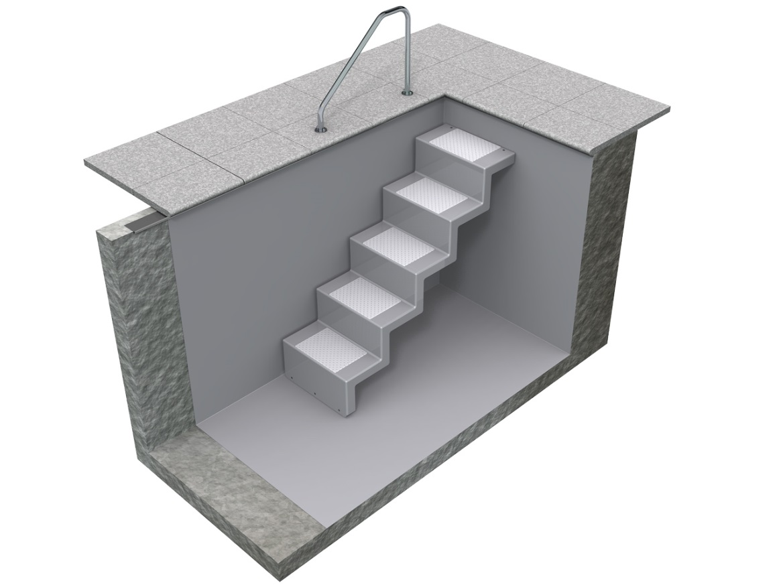
5 steps, short version, fixed with 2 bolts in the wall, with rubber plates on the floor.

Dimensions: 600 mm x 1500 mm

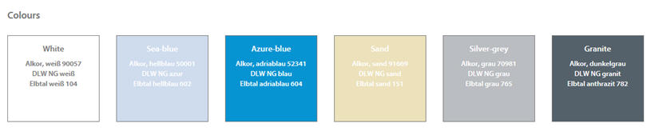

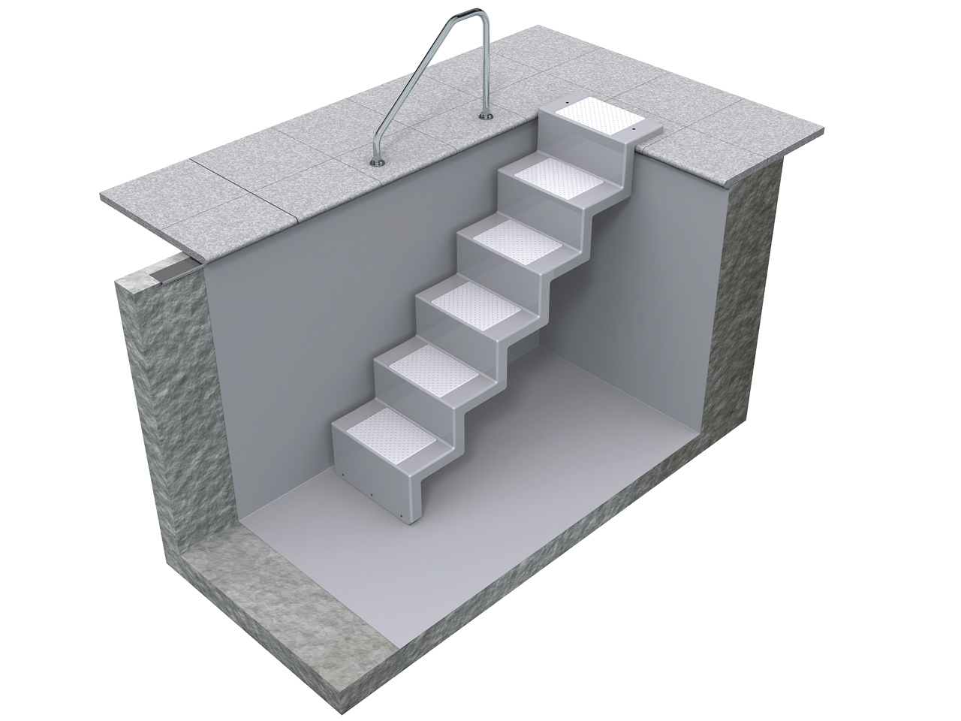

5 steps, long version, fixed with 2 bolts on the upper edge, with rubber plates on the floor drilling through the liner is not necessary.

- ELEGANZ Einbaudetails - LANG

Eleganz 60 “U” K
art. No.: Ele60"U" CL K
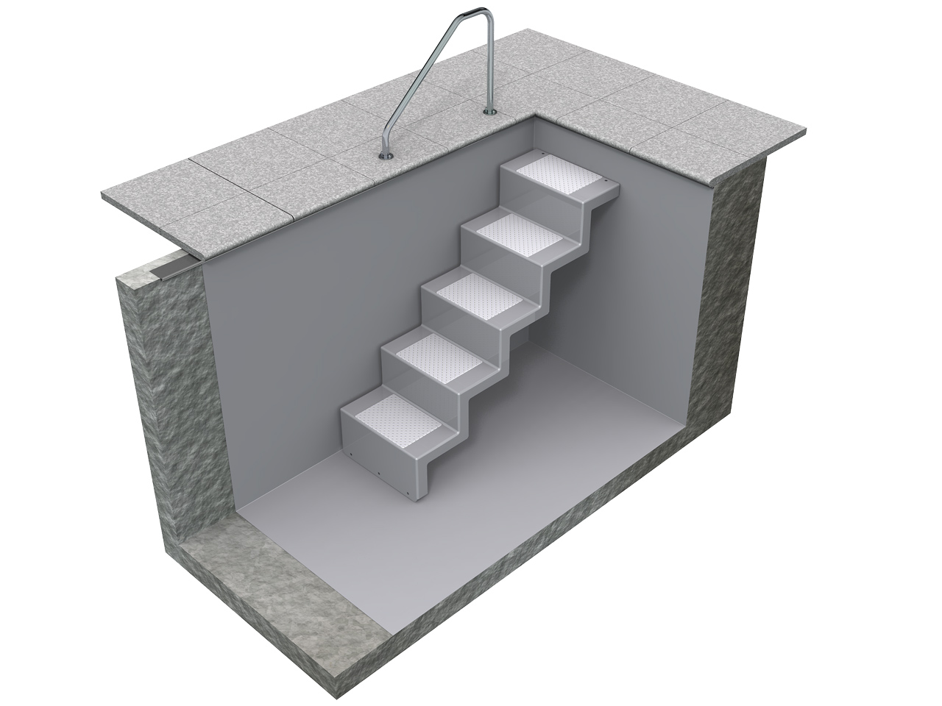

Dimensions: 600 mm x 1300 mm
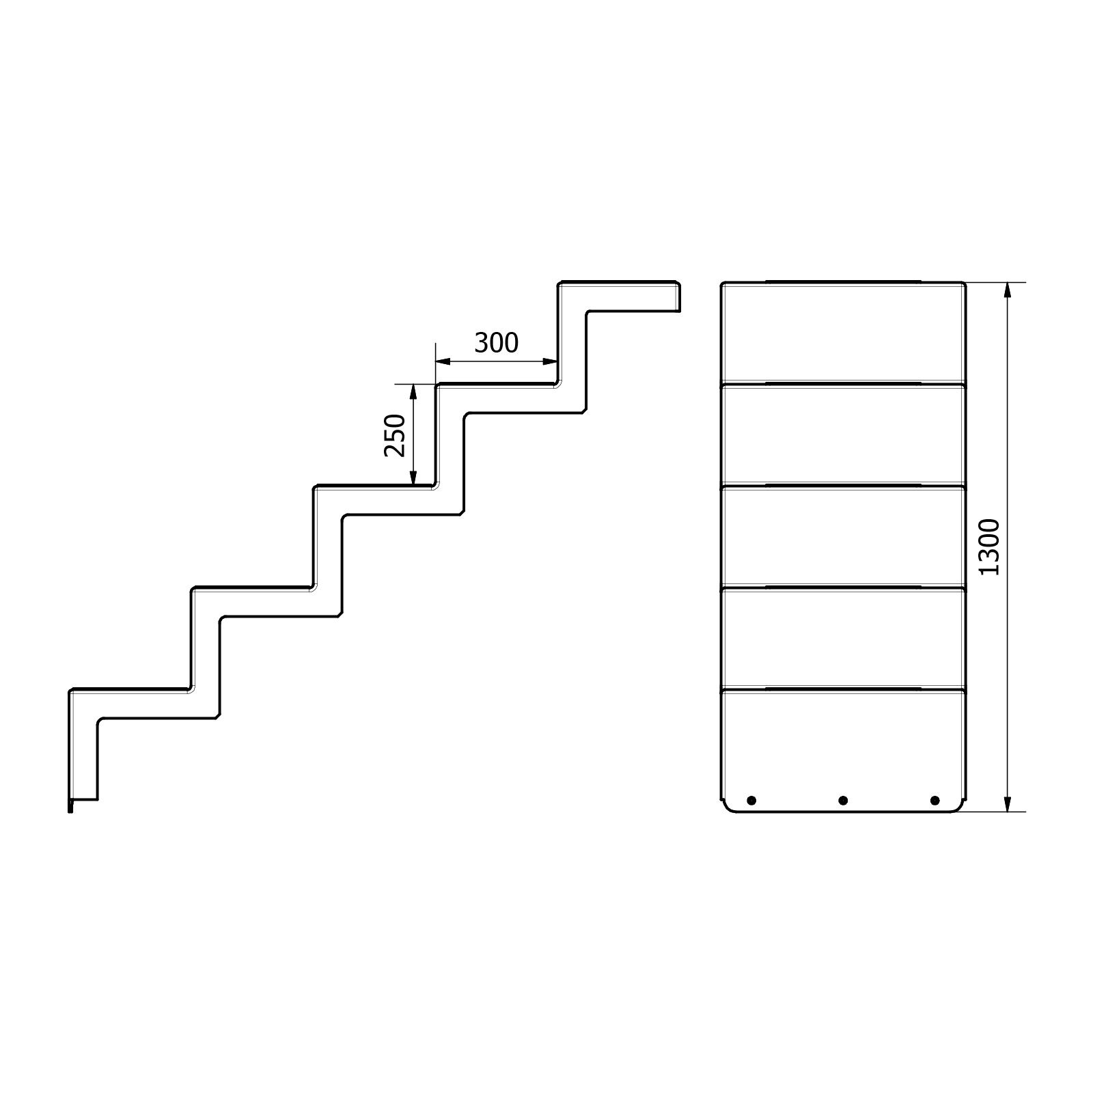
- ELEGANZ Einbaudetails - KURZ

